Home page https://staging.txa.com.au/
- Image needs to be like V3leisure home page
- Date the ATDW partnership (2008)
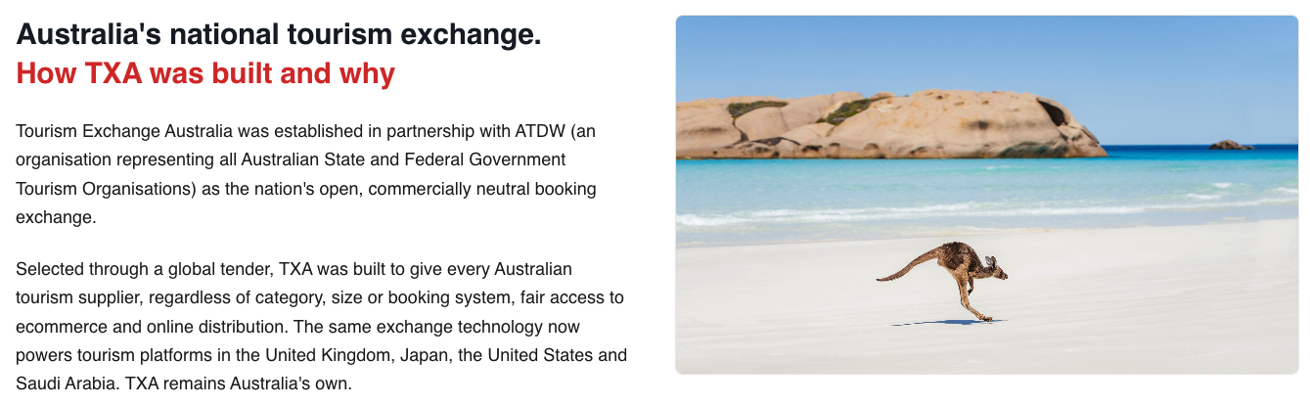
- A Connected Tourism Ecosystem diagram - Distribution platforms and channels needs to lift when cursor passes over
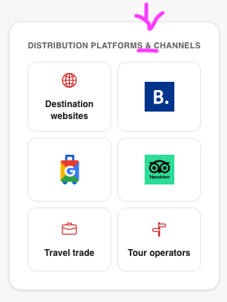
- Discover and book
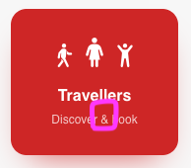
- TXA connection pathway

- Replace animated video with the TXA explainer on the home page of the current site (it will need an edit and re-voice but we can do that when we get a chance)
- Learn about data and insights
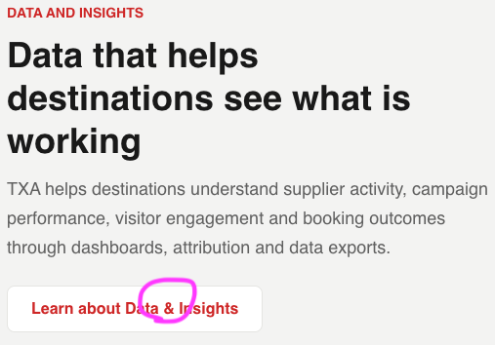
- Change all & to and
Suppliers https://staging.txa.com.au/suppliers/
- CRM change to Performance Insights
- Database change to Customer booking data
- TXA System changes to content, live availability and rates
- Icon is missing for Content, Live Availability and Rates (TXA System)
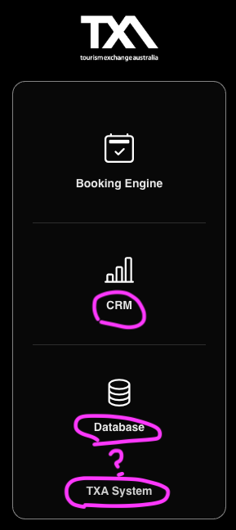
- Company website change to Supplier’s own website
- Web platforms changes to Social media channels
- ADD Travel trade
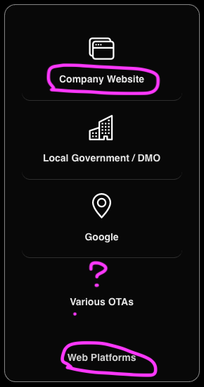
- Under Connection options change to “Options for suppliers without a suitable booking system, or alternative supported connection pathways.”
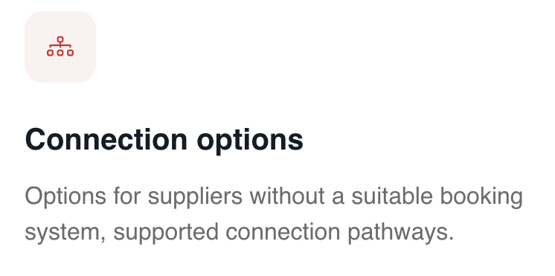
Destinations https://staging.txa.com.au/destinations/
- and facilitate create virtual concierge collaborative commerce
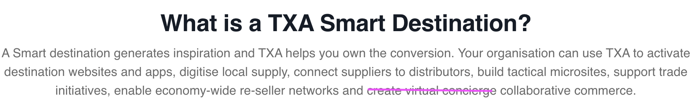
- “Own your data” boarders?
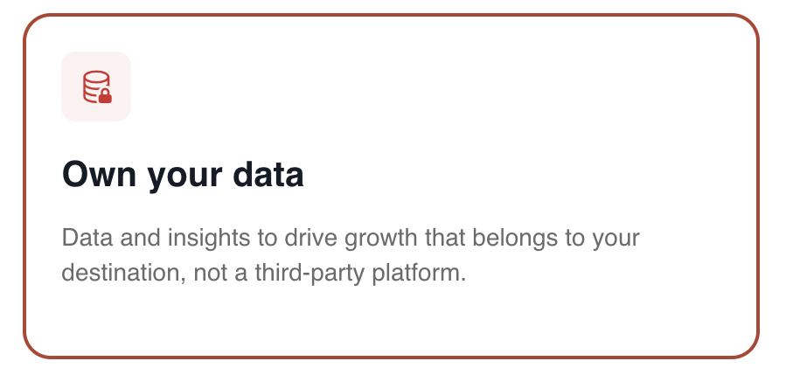
- Define Assets for Activation
- Define the destination assets for activation
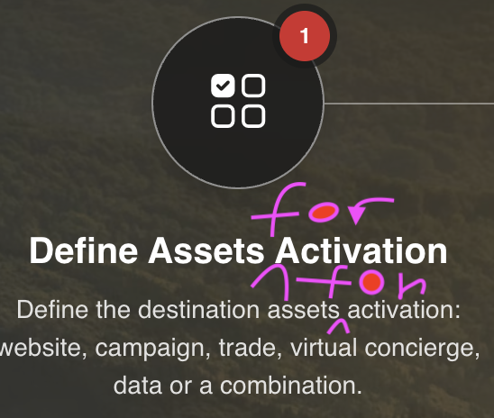
destinations/pricing/ https://staging.txa.com.au/destinations/pricing/
- ADD sub head “Destination packages include:”
- What happens if they click ‘Select local package etc…
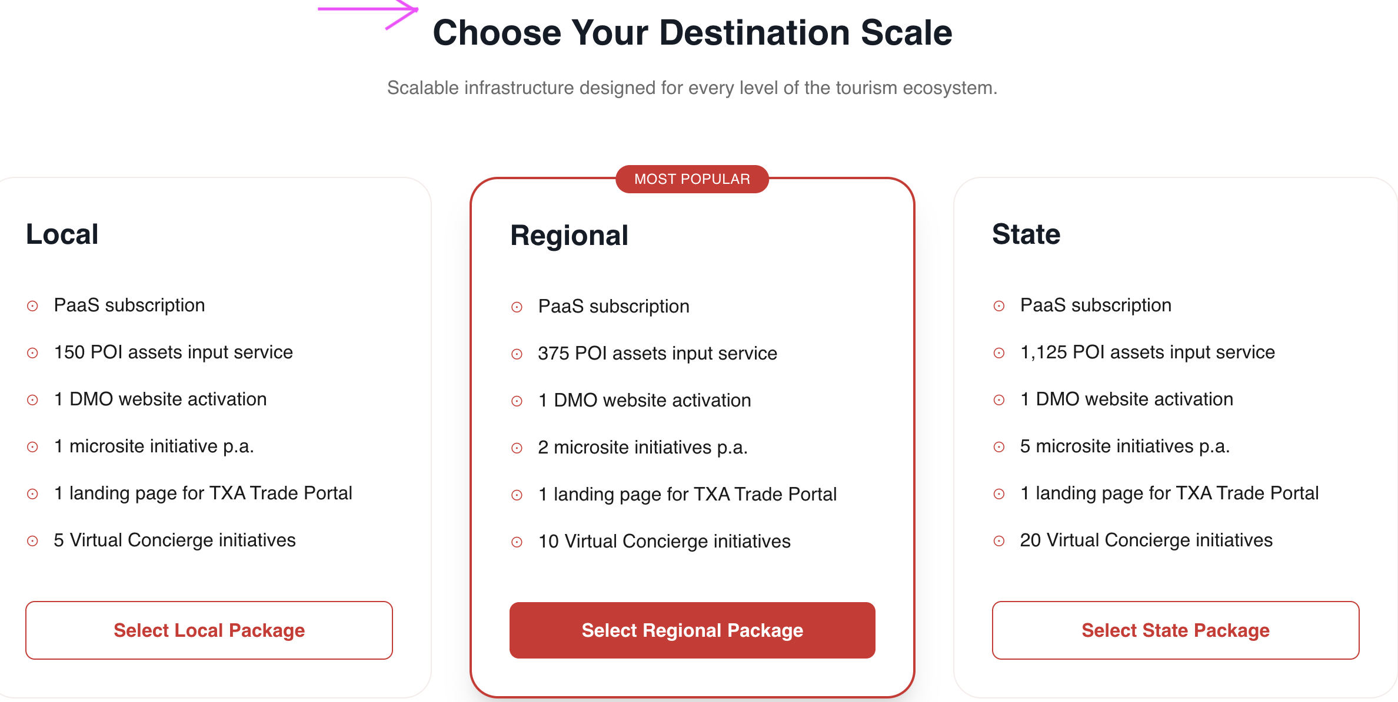
- Change to Small One-time charge
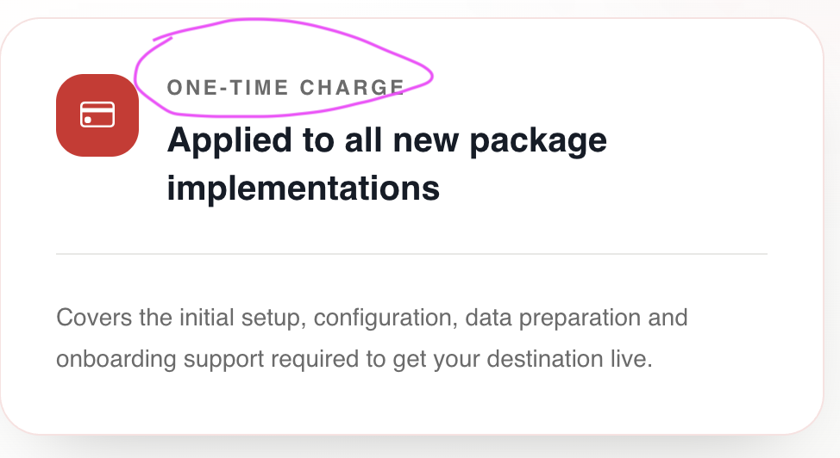
destinations/poi-experiences/
- Learn how??
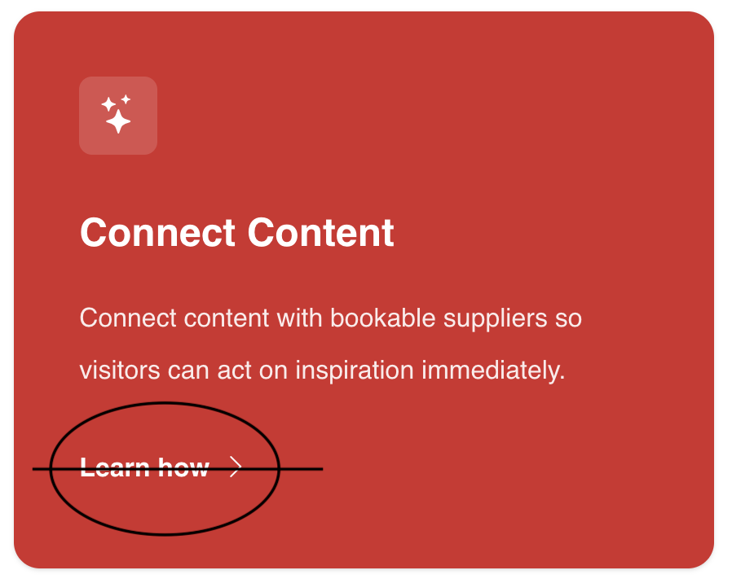
destinations/trade-portal/
- landing page in in Australia's National…
- 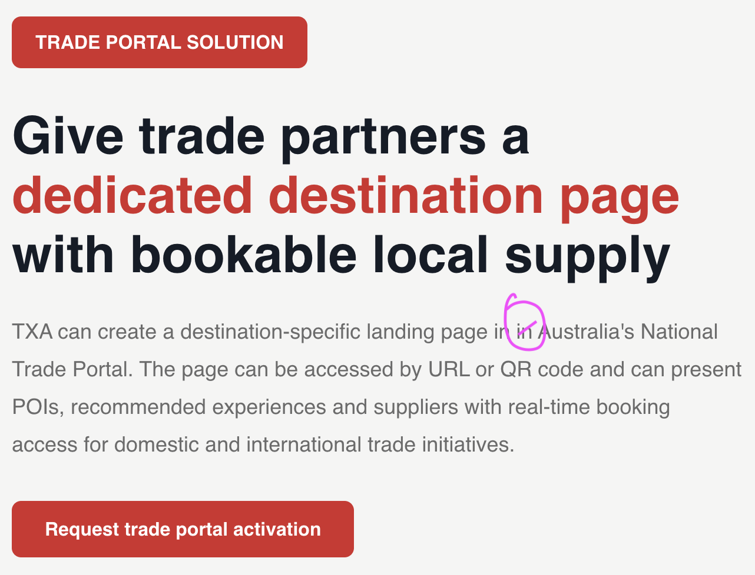
- Increase size and mabe caps/bold Domestic & and international trade partners
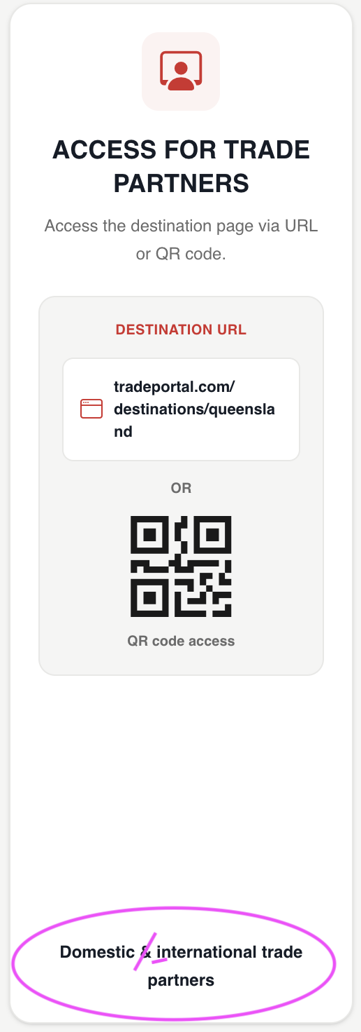
- Integrated Local Supply and Booking
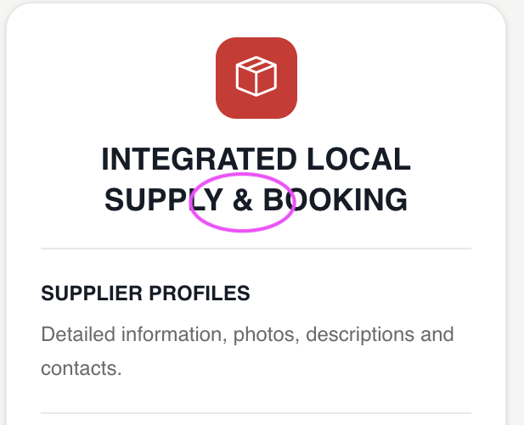
- Add payment methods “On-account or direct to supplier payment”
- Where should Learn about QR integration link to?
destinations/virtual-concierge/ https://staging.txa.com.au/destinations/virtual-concierge/
- Leave the url as is but change as follows
- Above the box insert UNIQUE COLLABORATIVE OPPORTUNITY
- Change the headline Virtual Concierge to TXA’s local reseller network or ‘Virtual Concierge’
- Change copy to TXA’s unique local re-seller network or ‘Virtual Concierge’ capability helps tourism product…
- Where should the Explore TXA’s virtual concierge box link to?
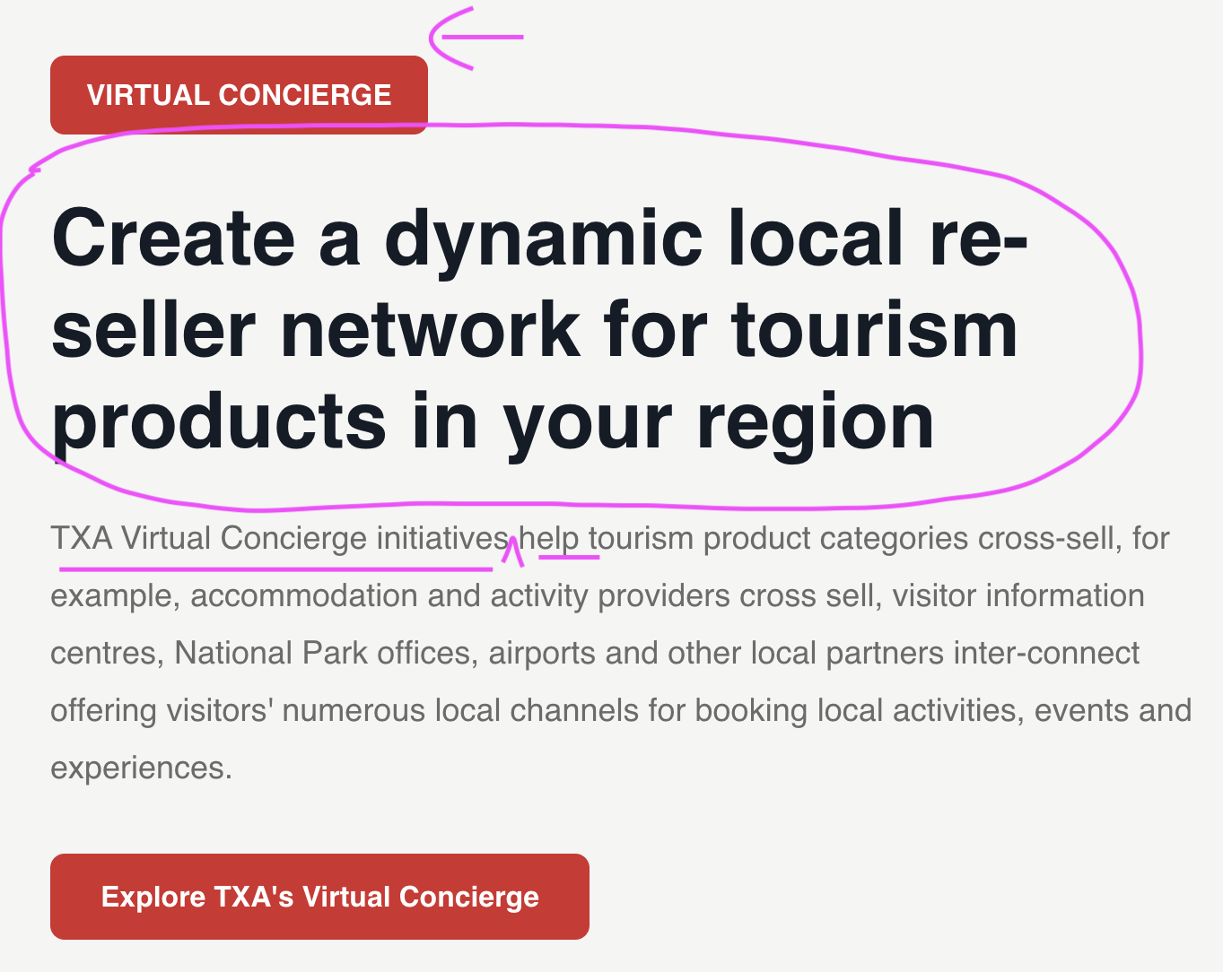
Distributors
- Same comment on this diagram Maybe use same format but focus on distribution box and amend (exclude supplier’s own website)
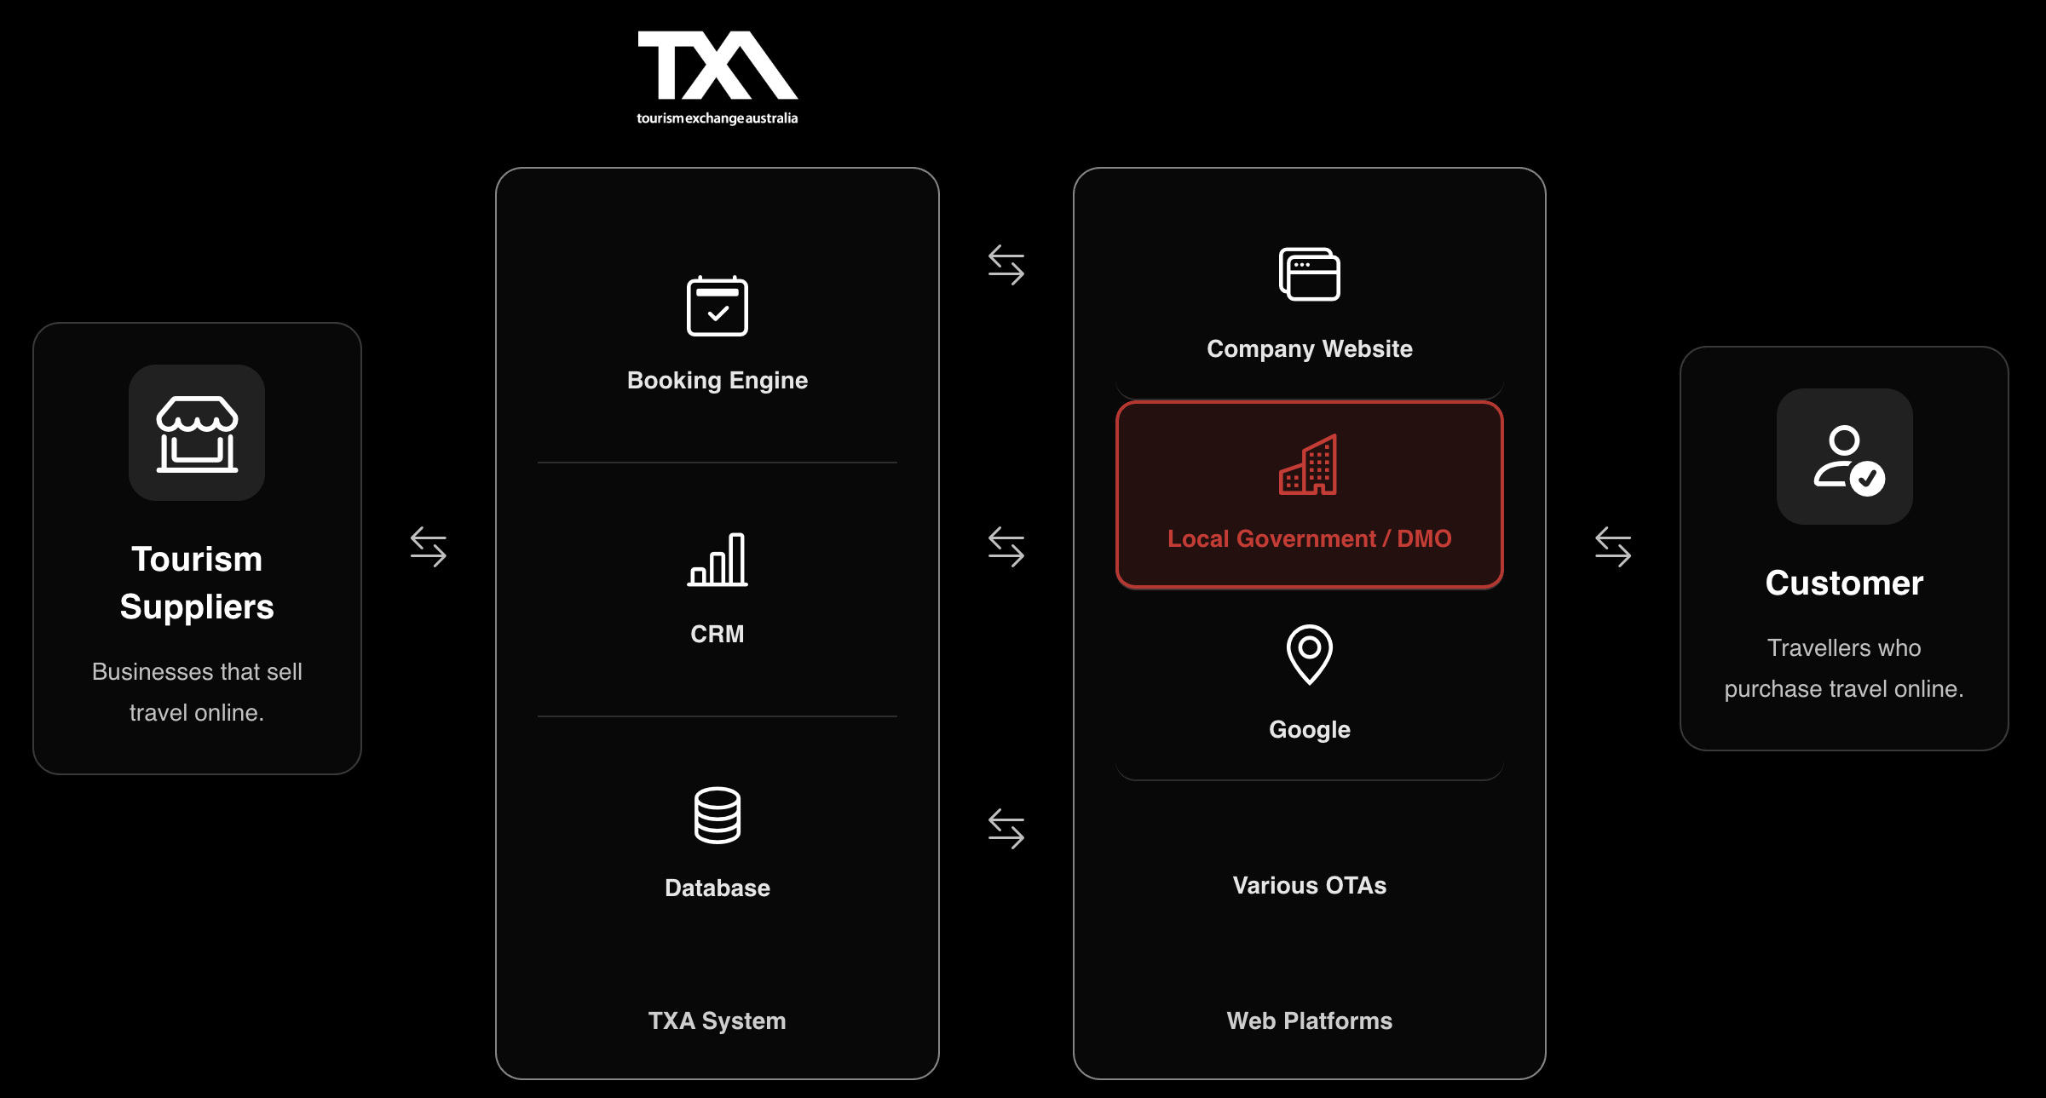
- Change Why distribute through TXA? To ‘Why use TXA to source Australian tourism suppliers’
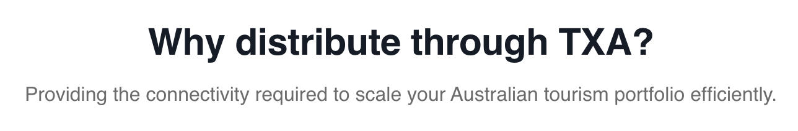
- Under Flexible distribution models add a box headed
- Direct to Supplier payment option.
  - Copy - Facilitates the Supplier transaction with the supplier as merchant. Distributors don’t have PCI compliance or GDPR. Supplier is the merchant but distributor still gets credited with commission
- Add another box - Simple and easy Supplier contracting
  - Copy – Simple opt-in opt-out model for contracting. Single supplier contract legally covers all suppliers. Simple, fast, efficient.
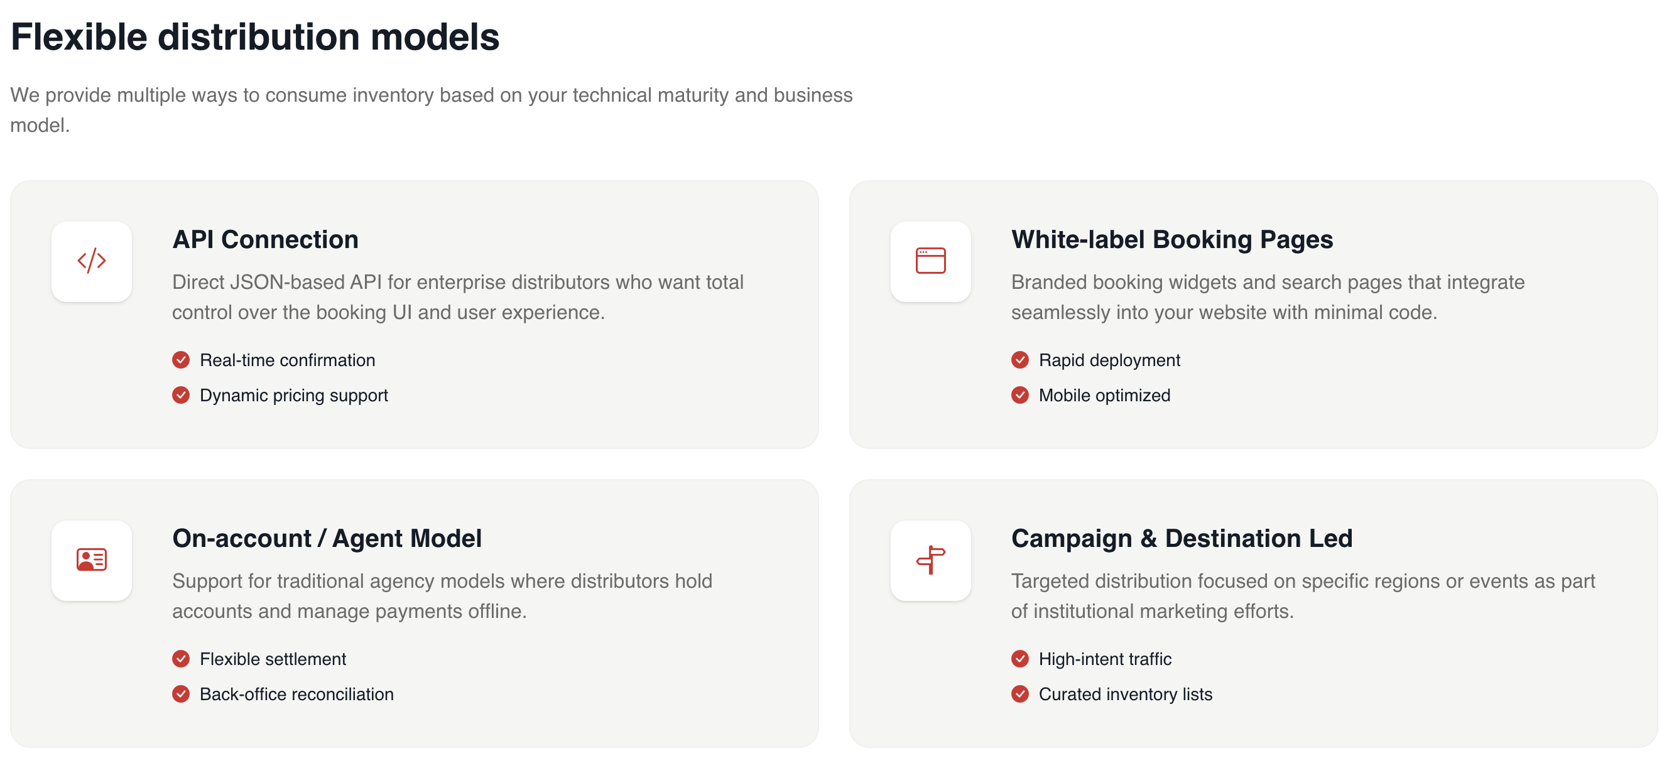
- Change image –
- Become a distributor goes to webform?
Booking systems https://staging.txa.com.au/booking-systems/
- Headline in box changes to TXA CONNECTED BOOKING SYSTEMS
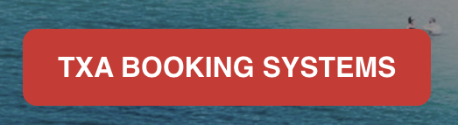
- Diagram needs work
  - Change TXA System to TXA PLATFORM
  - Delete -TXA System
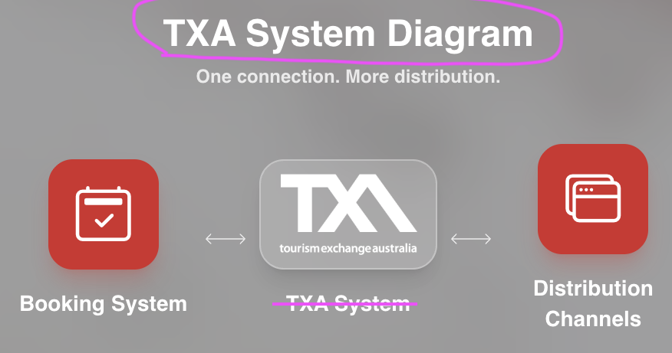
- Delete limited release under Siteminder
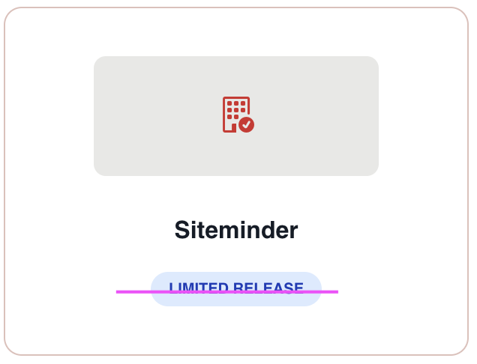
- Make sure Little Hotelier is included
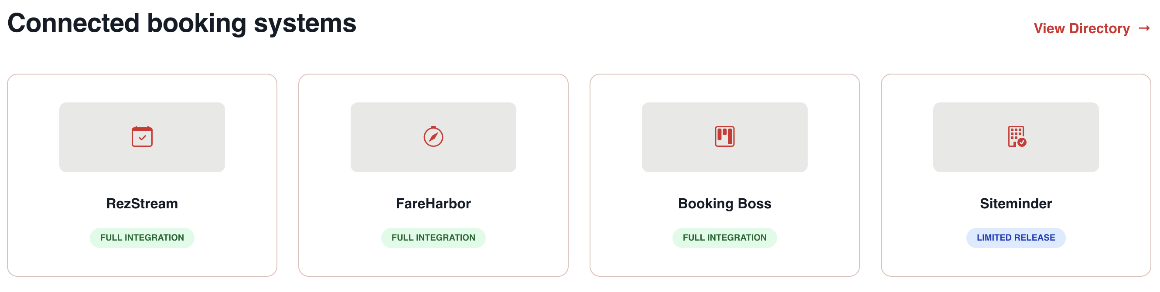
- Panel ‘Fee to connect’?
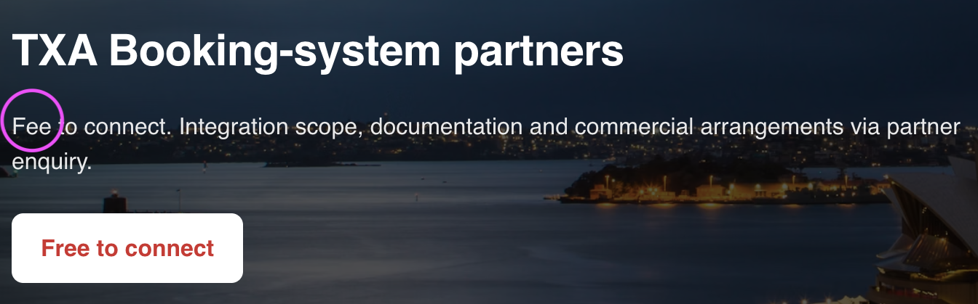
Pricing https://staging.txa.com.au/pricing/
- Delete 0 from numbers just 1, 2 3 as per contact page
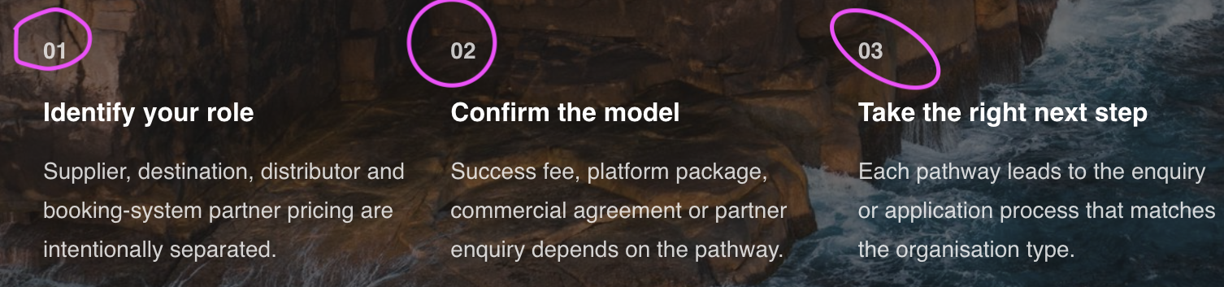
- Choose your role in TXA
- Where do the links go?
- Supplier Focus changes to Are you a Supplier?
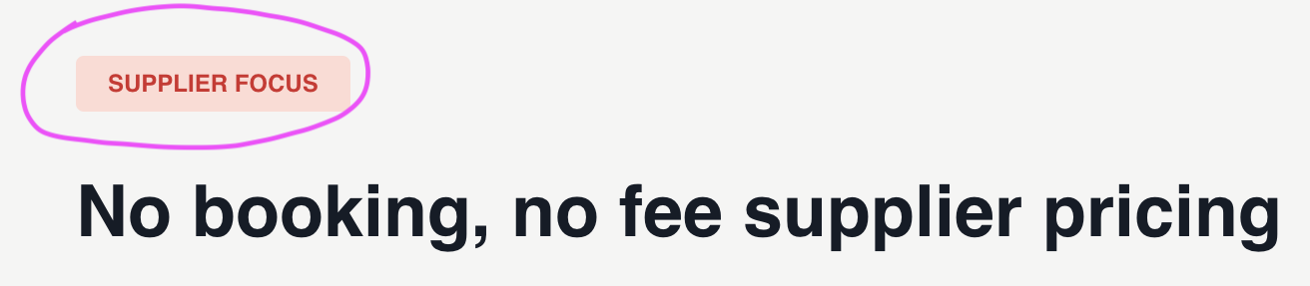
- Use same box for the others Are you a Destination?, Are you a Distributor?, Are you a Booking System Vendor?
- Missing a Destination box Are you a Destination Manager?
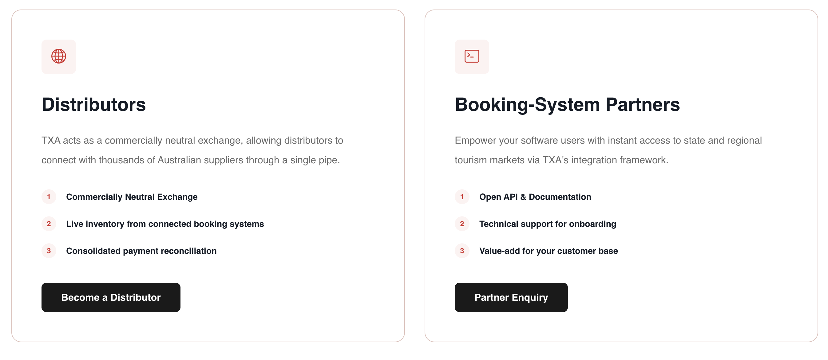
About
- Use other TX territory logos

- SW to edit timeline
Blogs
FAQs Doesn’t necessarily need a separate page
- Didn’t see them in the body copy?

